



**Customer Retention Analysis**

**E-retail factors for customer activation and retention: A case study from Indian e-commerce customers**

**Submitted by:**



**Sudhanshu Kumar**



**ACKNOWLEDGMENT**

## I would like to thanks to **Flip Robo Technologies** to give me a wonderful opportunity. This project is given by my **SME Mr. Shubham Yadav**. I have referred below resources that helped and guided me in completion of this project as below:-

* Towardsscience.com
* Scikit-learn.org
* Kaggle.com
* Stack overflow, etc



**Data source**

The data is collected from the Indian online shoppers. Results indicate the e-retail success factors, which are very much critical for customer satisfaction.



**INTRODUCTION**



**What is customer retention**

Customer retention is the collection of activities a business uses to increase the number of repeat customers and to increase the profitability of each existing customer.

Customer retention strategies enable us to both provide and extract more value from our existing customer base. We want to ensure the customers we worked so hard to acquire stay with us, have a great customer experience, and continue to get value from our products.

# Business Problem Framing



Customer satisfaction has emerged as one of the most important factors that guarantee the success of online store; it has been posited as a key stimulant of purchase, repurchase intentions and customer loyalty. A comprehensive review of the literature, theories and models have been carried out to propose the models for customer activation and customer retention. Five major factors that contributed to the success of an e-commerce store have been identified as: service quality, system quality, information quality, trust and net benefit. The research furthermore investigated the factors that influence the online customers repeat purchase intention. The combination of both utilitarian value and hedonistic values are needed to affect the repeat purchase intention (loyalty) positively. The data is collected from the Indian online shoppers. Results indicate the e-retail success factors, which are very much critical for customer satisfaction.

**The company wanted to a data analysis to understand various aspect of customer satisfaction.**

# Conceptual Background of the Domain Problem



**Problem Statement**: Analyse the Features affecting Customer Satisfaction & retention and test if brand preference depends on factors like age and gender.

The combination of both utilitarian value and hedonistic values are needed to affect the repeat purchase intention (loyalty) positively.

The data is collected from the Indian online shoppers. Results indicate the e- retail success factors, which are very much critical for customer satisfaction.

**Five major factors** that contributed to the **success of an e-commerce store**

have been identified as:

1. Service quality,
2. System quality,
3. Information quality,
4. Trust
5. Net benefit



* Review of Literature:

E-commerce market has been contributing to the significant growth for the GDP of the country. It has been continuously growing at more 8% CAGR on each year. And customer being a one of the stakeholders for the e-commerce players, every company wants to retain their valuable customer and grow customer loyalty. For improving the customer satisfaction each enterprise investing/spending a lot not only to improve their sales but improve the CSAT, that is customer satisfaction score.

For this project we are provided with a data set to a data analysis to gather insights for the customer feedback and help us understand the customer in a better way.



**Diagrammatic Representation of Customer Retention**

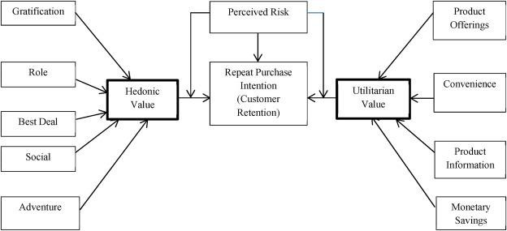

**Motivation for the Problem Undertaken**

Since e-commerce growth has been significant so far at each industry for the last couple of years, understanding the customer who purchase your product and their journey post order in the platform plays a crucial role for retaining a customer. From the dataset we got the feedback of each of the parameters for a customer and through the data analysis each significant parameter has been dig down and understand the deeper meaning of it. This project helps me understand the objective of customer feedback which at enterprise level has a greater focus.



**Analytical Problem Framing**



Mathematical/ Analytical Modeling of the Problem

* + In this project I need to understand the customer satisfaction for each of the parameters provided. I have done the exploratory data analysis process and try to figure out the customer in a better way.



Data Sources and their formats

This Dataset is **provided by Flip Robo Technologies xlsx format**. It contains 269 rows and 71 columns and each of the features is extremely important to under the customer.

# Check the data information cus_ret.info()

<class 'pandas.core.frame.DataFrame'> RangeIndex: 269 entries, 0 to 268 Data columns (total 71 columns):

# Column Non-Null

Count Dtype

--- ------ --------

------ -----

1. Gender 269 non-

null object

1. Age 269 non-

null object

1. city 269 non-

null object

3 Pin Code 269 non

null int64

4 How Long You are Shopping Online 269 non

null object

5 How many times in the past 1 year 269 non

null object

6 How do you access the internet 269 non

null object

7 device 269 non

null object

8 screen size 269 non

null object

9 operating system 269 non

null object

10 browser 269 non

null object

11 channel 269 non

null object

12 After first visit 269 non

null object

13 How much times 269 non

null object

14 payment Option 269 non

null object

15 How frequently do you abandon 269 non

null object

16 Why did you abandon 269 non

null object

17 content on the website 269 non

null object

18 similar product 269 non

null object

19 Complete information 269 non

null object

20 relevant information 269 non

null object

21 Ease of navigation 269 non

null object

22 Loading and processing speed 269 non

null object

23 User friendly 269 non

null object

24 Convenient Payment methods 269 non

null object

25 Trust that the online retail store 269 non

null object

26 Empathy towards the customers 269 non

null object

27 privacy of the customer 269 non

null object

28 Responsiveness and availability 269 non

null object

29 monetary benefit and discounts 269 non

null object

30 Enjoyment is derived from shopping online 269 non

null object

31 Shopping online is convenient and flexible 269 non

null object

32 Return and replacement policy 269 non

null object

33 Gaining access to loyalty 269 non

null object

34 quality Information on the website 269 non

null object

35 User derive satisfaction 269 non

null object

36 Net Benefit 269 non

null object

37 User satisfaction cannot exist without trust 269 non

null object

38 Offering a wide variety 269 non

null object

39 Provision of complete and relevant product information 269 non

null object

40 Monetary savings 269 non

null object

41 The Convenience of patronizing the online retailer 269 non

null object

42 sense of adventure 269 non

null object

43 enhances your social status 269 non

null object

44 gratification shopping on your favorite e-tailer 269 non

null object

45 Shopping on the website helps you fulfill certain roles 269 non

null object

46 Getting value for money spent 269 non

null object

47 you have shopped from 269 non

null object

48 Easy to use website or application 269 non

null object

49 Visual appealing web-page layout 269 non

null object

50 Wild variety of product on offer 269 non

null object

51 Complete description information of products 269 non

null object

52 Fast loading website speed of website and application 269 non

null object

53 Reliability of the website or application 269 non

null object

54 Quickness to complete purchase 269 non

null object

55 Availability of several payment options 269 non

null object

56 Speedy order delivery 269 non

null object

57 Privacy of customers’ information 269 non

null object

58 Security of customer financial information 269 non

null object

59 Perceived Trustworthiness 269 non

null object

60 Presence of online assistance through multi-channel 269 non

null object

61 Longer time to get logged in 269 non

null object

62 Longer time in displaying graphics and photos 269 non

null object

63 Late declaration of price 269 non

null object

64 Longer page loading time 269 non

null object

65 Limited mode of payment on most products 269 non

null object

66 Longer delivery period 269 non

null object

67 Change in website/Application design 269 non

null object

68 Frequent disruption when moving from one page to another 269 non

null object

69 Website is as efficient as before 269 non

null object

70 Which of the Indian online retailer would you recommend to a friend 269 non

null object

dtypes: int64(1), object(70)

memory usage: 149.3+ KB

• Hardware and Software Requirements and Tools

Used:

For this dataset, the Hardware is used Windows as operating system, a

stable internet connection, and the software used are mainly Jupyter

notebook to do my python programming and analysis.

I received data in xlsx format, I had used few libraries on **Jupyter Notebook**

for this project. The Libraries are:

1. **Pandas**- a library which is used to read the data,

visualization, and analysis of data.

2. **NumPy**- used for working with array and various

mathematical techniques.

3. **Seaborn**- visualization tool for plotting different types of plot.

4. **Matplotlib**- It provides an object-oriented API for

embedding plots into applications.

**Data Analysis Development and Evaluation**

Identification of possible problem-solving approaches

(methods):

For this project I have done EDA to understand the outcome of this dataset. And, I

have used various visualization using seaborn & matplotlib package to understand

the customer satisfaction in a suitable manner.

Key Metrics for success in solving problem under

Consideration:

The key metrics that were mainly taken into consideration were the

followings:

➢ Gender of the respondent

➢ What browser do you run on your device to access the website?

➢ Which device do you use to access the online shopping?

➢ Which of the Indian online retailer would you recommend to a friend?

➢ Quickness to complete purchase

➢ Speedy order delivery

➢ Presence of online assistance through multi-channel

➢ Getting value for money spent

➢ Return and replacement policy of the e-tailer is important for purchase decision

➢ Shopping online is convenient and flexible

➢ Convenient Payment methods

➢ User friendly Interface of the website

EDA Process

And

Visualization



**Exploratory Data Analysis**

**Customer Related Information**

plt.figure(figsize=(15,5))

plt.xticks(rotation=45)

print(cus_ret['Gender'].value_counts())

cus_ret['Gender'].value_counts().sort_index().plot.bar()

<AxesSubplot:>

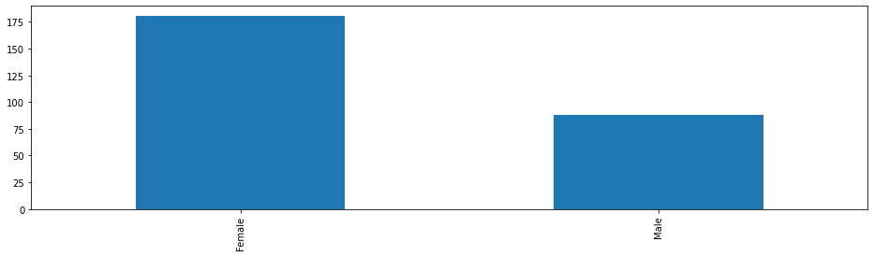

Female 181

Male 88

Name: Gender, dtype: int64

**From the above analysis, it has been observed that around 67% of**

**the customers are women.**

plt.figure(figsize=(15,5))

plt.xticks(rotation=45)

print(cus_ret['Age'].value_counts())

sns.countplot(cus_ret['Age'])

<AxesSubplot:xlabel='Age', ylabel='count'>

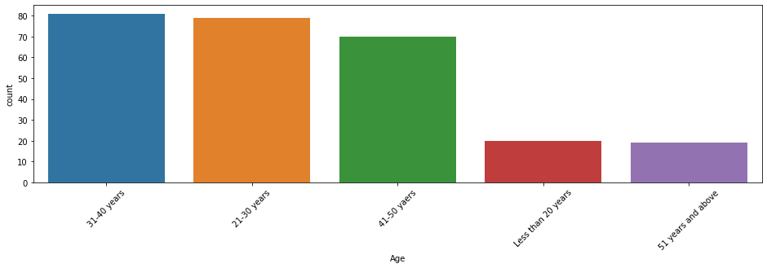

31-40 years 81

21-30 years 79

41-50 yaers 70

Less than 20 years 20

51 years and above 19

Name: Age, dtype: int64

**Most of the customers are aged between 31 to 40 years do online shopping, next comes the customers aged between 21 to 30 years old and so on as shown in graph above.**

plt.figure(figsize=(15,5))

plt.xticks(rotation=45)

print(cus_ret['city'].value_counts())

sns.countplot(cus_ret['city'])

<AxesSubplot:xlabel='city', ylabel='count'>

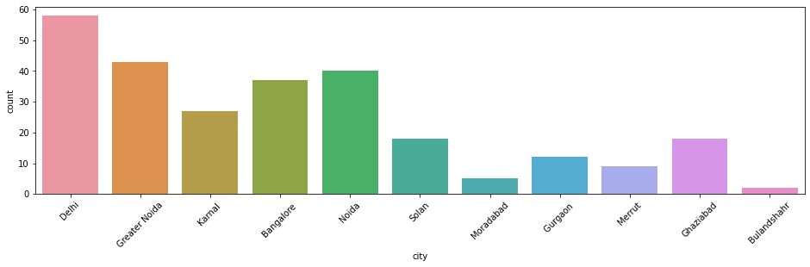

Delhi 58

Greater Noida 43

Noida 40

Bangalore 37

Karnal 27

Solan 18

Ghaziabad 18

Gurgaon 12

Merrut 9

Moradabad 5

Bulandshahr 2

Name: city, dtype: int64

**Customers from Delhi have the highest online shopping actions**

**than comes the Greater Noida and least online shopping is in**

**Bulandshahar.**

**So, we can also say that the people from Metro Cities like Delhi**

**NCR, Bangalore are more preferred or active on online shopping**

**sites.**

plt.figure(figsize=(15,5))

plt.xticks(rotation=45)

print(cus_ret['How do you access the internet'].value_counts())

cus_ret['How do you access the internet'].value_counts().plot.line()

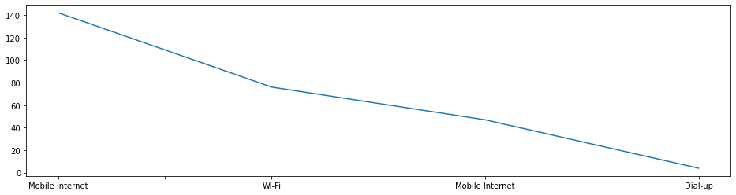

Mobile internet 142

Wi-Fi 76

Mobile Internet 47

Dial-up 4

Name: How do you access the internet, dtype: int64

Checking the number of people using which device for online shopping

plt.figure(figsize=(15,5))

plt.xticks(rotation=45)

print(cus_ret['device'].value_counts())

sns.countplot(cus_ret['device'])

<AxesSubplot:xlabel='device', ylabel='count'>

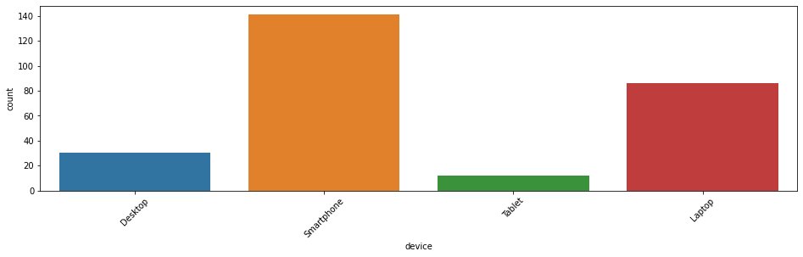

Smartphone 141

Laptop 86

Desktop 30

Tablet 12

Name: device, dtype: int64

**Here we can see that mostly people are using smartphone for**

**online shopping. So, we can say that people are very comfortable**

**to use smartphone and It is easier to operate than another device.**

plt.figure(figsize=(15,5))

plt.xticks(rotation=45)

print(cus_ret['How Long You are Shopping Online'].value_counts())

cus_ret['How Long You are Shopping Online'].value_counts().plot.line()

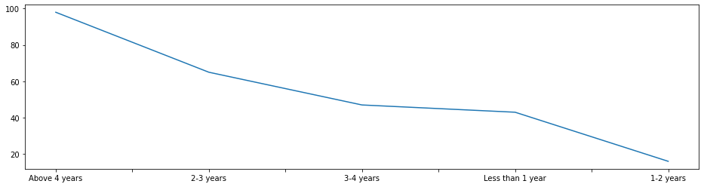

Above 4 years 98

2-3 years 65

3-4 years 47

Less than 1 year 43

1-2 years 16

Name: How Long You are Shopping Online, dtype: int64

plt.figure(figsize=(15,5))

plt.xticks(rotation=45)

print(cus_ret['operating system'].value_counts())

sns.countplot(cus_ret['operating system'])

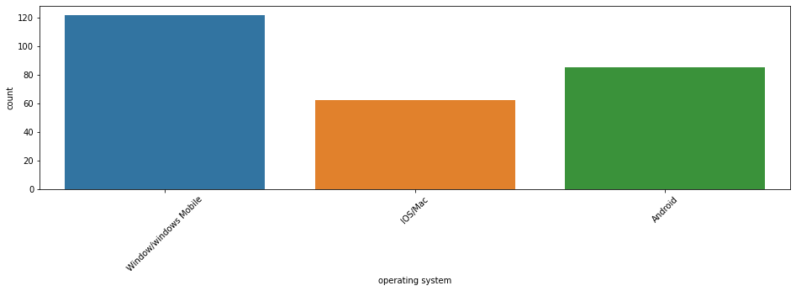

Window/windows Mobile 122

Android 85

IOS/Mac 62

Name: operating system, dtype: int64

Checking which browser preferred by people for online shoppings

plt.figure(figsize=(15,5))

plt.xticks(rotation=45)

print(cus_ret['browser'].value_counts())

sns.countplot(cus_ret['browser'])

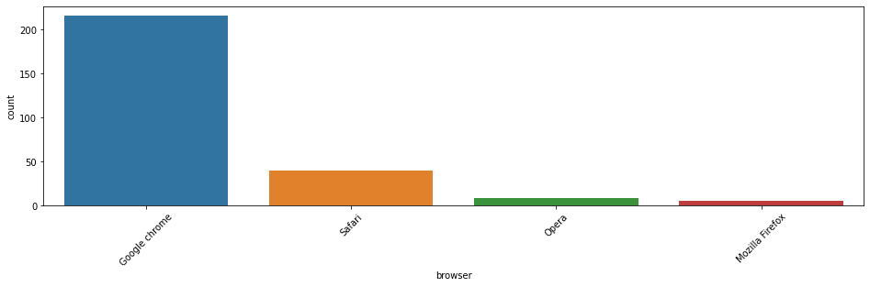

Google chrome 216

Safari 40

Opera 8

Mozilla Firefox 5

Name: browser, dtype: int64

**According to analysis, Google Chrome has the highest usage**

**browser for online shoppings or we can say that people has lots of**

**faith on Google Chrome for online transactions or shoppings. This**

**is the biggest achievement for Google.**

plt.figure(figsize=(15,5))

plt.xticks(rotation=45)

print(cus_ret['channel'].value_counts())

sns.countplot(cus_ret['channel'])

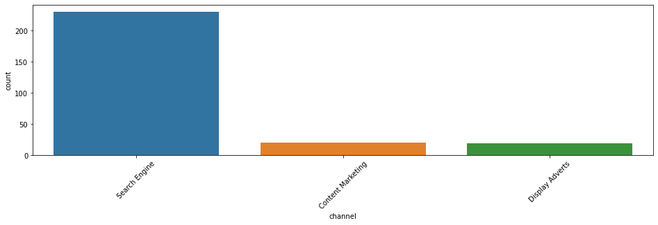

Search Engine 230

Content Marketing 20

Display Adverts 19

Name: channel, dtype: int64

**Conclusion from Customer Related Information**

**Analysis :**

**1) In people doing online shopping Females are more as compared to Males.**

**2) People in the age group from 21 to 50 are doing more online shopping as compared to**

**other age groups.**

**3) Delhi Topped in the city list where a greater number of people doing online shopping.**

**4) Mostly people are using mobile internet while shopping online.**

**5) Mostly People are doing online shopping through smartphone.**

**6) People having windows as operating system(OS) have maximum count.**

**7) Mostly people are choosing google chrome as browser to access the website**

**8) People are mostly use search engine to arrive at their favourite online store for the first**

**time.**

**9) After first visit people are using application or search engine to access website.**

cus_ret['How many times in the past 1 year'].value_counts().plot.barh()

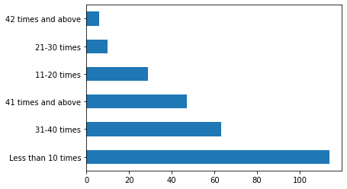

**Most customers fall under the category of less than 10 orders per**

**year, around the same number fall under the category where no of**

**orders is more than 30 .**

**The number of customers who made more than 30 would be our**

**area of interest are they are loyal customers / likely to purchase**

**more.**

plt.figure(figsize=(15,5))

plt.xticks(rotation=45)

print(cus_ret['payment Option'].value_counts())

sns.countplot(cus_ret['payment Option'])

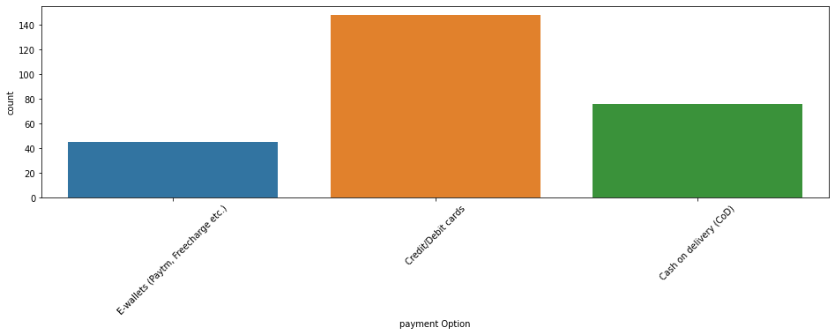

Credit/Debit cards 148

Cash on delivery (CoD) 76

E-wallets (Paytm, Freecharge etc.) 45

Name: payment Option, dtype: int64

**Mostly people are using credit and debit cards as their preferred**

**payment option.**

plt.figure(figsize=(15,5))

plt.xticks(rotation=45)

print(cus_ret['Why did you abandon'].value_counts())

cus_ret['Why did you abandon'].value_counts().plot.line()

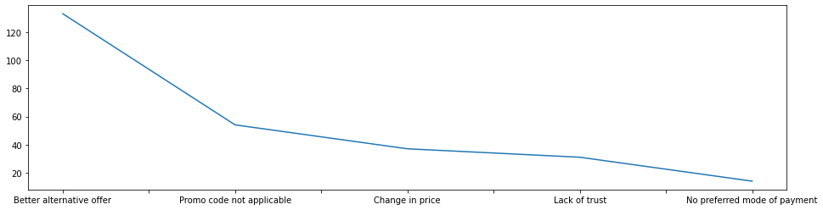

Better alternative offer 133

Promo code not applicable 54

Change in price 37

Lack of trust 31

No preferred mode of payment 14

Name: Why did you abandon, dtype: int64

**Now we are analysing the**

**Feed-Back from Customers**

plt.figure(figsize=(15,5))

plt.xticks(rotation=45)

print(cus_ret['User friendly'].value_counts())

sns.countplot(cus_ret['User friendly'])

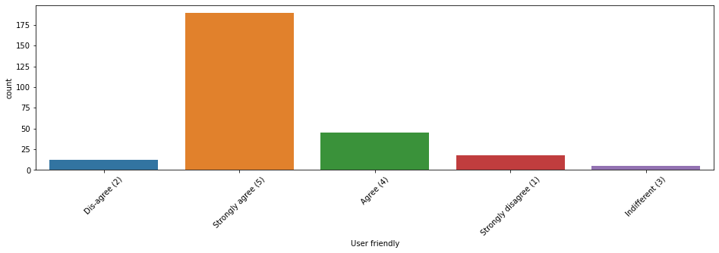

Strongly agree (5) 189

Agree (4) 45

Strongly disagree (1) 18

Dis-agree (2) 12

Indifferent (3) 5

Name: User friendly, dtype: int64

plt.figure(figsize=(15,5))

plt.xticks(rotation=45)

print(cus_ret['Convenient Payment methods'].value_counts())

sns.countplot(cus_ret['Convenient Payment methods'])

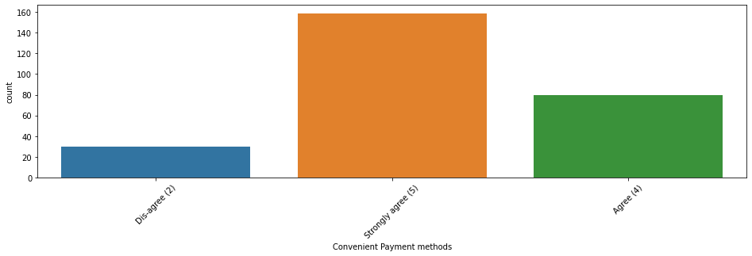

Strongly agree (5) 159

Agree (4) 80

Dis-agree (2) 30

Name: Convenient Payment methods, dtype: int64

plt.figure(figsize=(15,5))

plt.xticks(rotation=45)

print(cus_ret['Responsiveness and availability'].value_counts())

sns.countplot(cus_ret['Responsiveness and availability'])

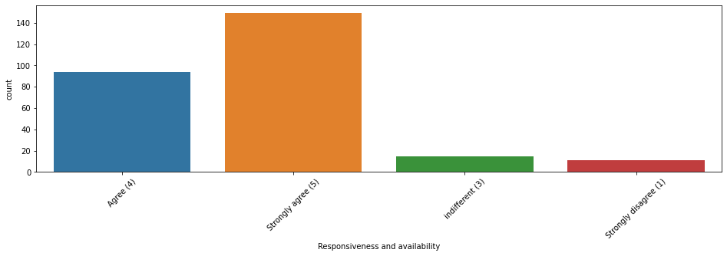

Strongly agree (5) 149

Agree (4) 94

indifferent (3) 15

Strongly disagree (1) 11

Name: Responsiveness and availability, dtype: int64

plt.figure(figsize=(15,5))

plt.xticks(rotation=45)

print(cus_ret['monetary benefit and discounts'].value_counts())

sns.countplot(cus_ret['monetary benefit and discounts'])

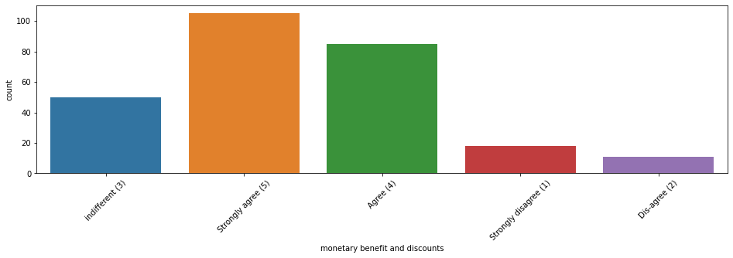

Strongly agree (5) 105

Agree (4) 85

indifferent (3) 50

Strongly disagree (1) 18

Dis-agree (2) 11

Name: monetary benefit and discounts, dtype: int64

plt.figure(figsize=(15,5))

plt.xticks(rotation=45)

print(cus_ret['quality Information on the website'].value_counts())

sns.countplot(cus_ret['quality Information on the website'])

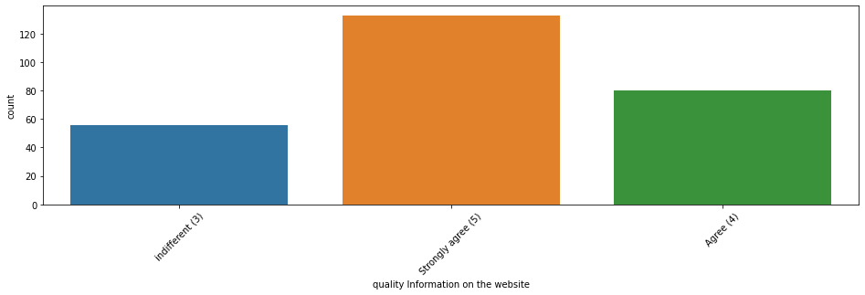

Strongly agree (5) 133

Agree (4) 80

indifferent (3) 56

Name: quality Information on the website, dtype: int64

plt.figure(figsize=(15,5))

plt.xticks(rotation=45)

print(cus_ret['Return and replacement policy'].value_counts())

sns.countplot(cus_ret['Return and replacement policy'])

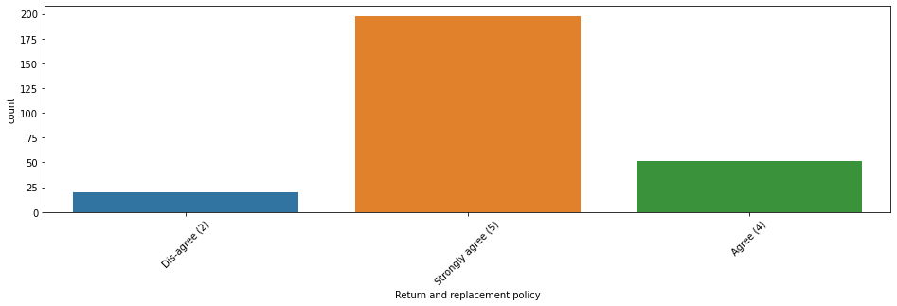

Strongly agree (5) 198

Agree (4) 51

Dis-agree (2) 20

Name: Return and replacement policy, dtype: int64

plt.figure(figsize=(15,5))

plt.xticks(rotation=45)

print(cus_ret['Getting value for money spent'].value_counts())

sns.countplot(cus_ret['Getting value for money spent'])

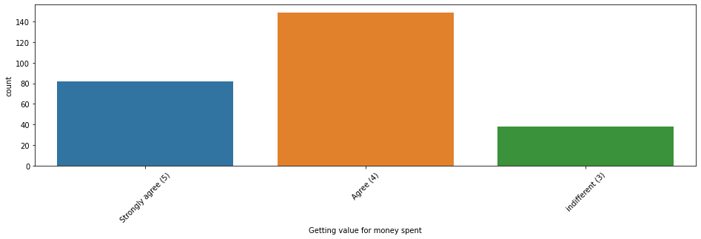

Agree (4) 149

Strongly agree (5) 82

indifferent (3) 38

Name: Getting value for money spent, dtype: int64

plt.figure(figsize=(15,5))

plt.xticks(rotation=45)

print(cus_ret['sense of adventure'].value_counts())

sns.countplot(cus_ret['sense of adventure'])

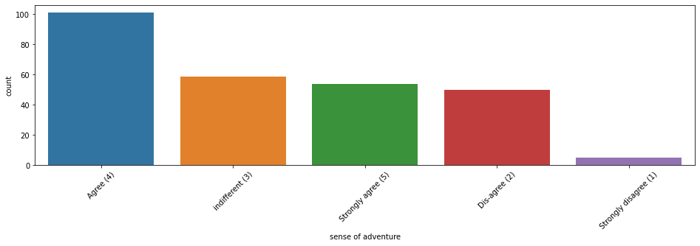

Agree (4) 101

indifferent (3) 59

Strongly agree (5) 54

Dis-agree (2) 50

Strongly disagree (1) 5

Name: sense of adventure, dtype: int64

plt.figure(figsize=(15,5))

plt.xticks(rotation=45)

print(cus_ret['privacy of the customer'].value_counts())

sns.countplot(cus_ret['privacy of the customer'])

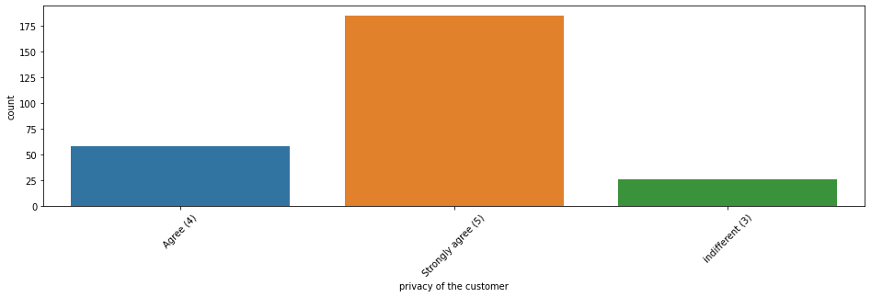

Strongly agree (5) 185

Agree (4) 58

indifferent (3) 26

Name: privacy of the customer, dtype: int64

plt.figure(figsize=(15,5))

plt.xticks(rotation=45)

print(cus_ret['Net Benefit'].value_counts())

sns.countplot(cus_ret['Net Benefit'])

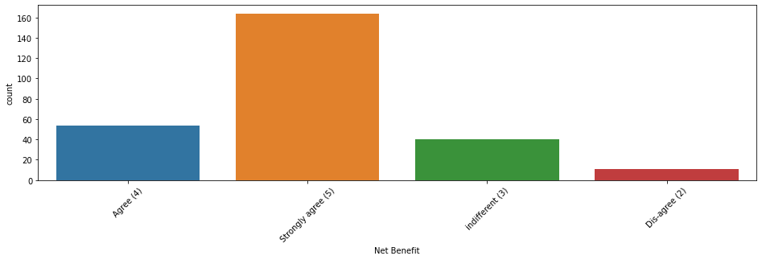

Strongly agree (5) 164

Agree (4) 54

indifferent (3) 40

Dis-agree (2) 11

plt.figure(figsize=(15,5))

plt.xticks(rotation=45)

print(cus_ret['Shopping online is convenient and flexible'].value_counts())

sns.countplot(cus_ret['Shopping online is convenient and flexible'])

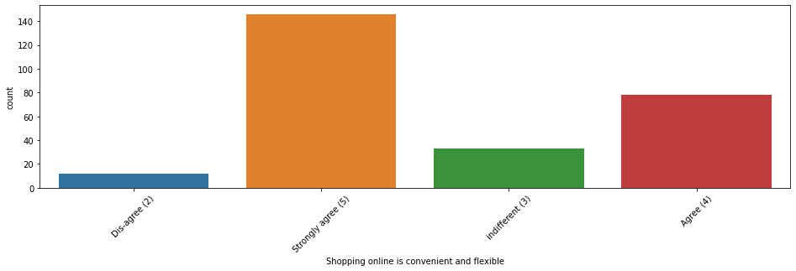

Strongly agree (5) 146

Agree (4) 78

indifferent (3) 33

Dis-agree (2) 12

Name: Shopping online is convenient and flexible, dtype: int64

plt.figure(figsize=(15,5))

plt.xticks(rotation=45)

print(cus_ret['Gaining access to loyalty'].value_counts())

sns.countplot(cus_ret['Gaining access to loyalty'])

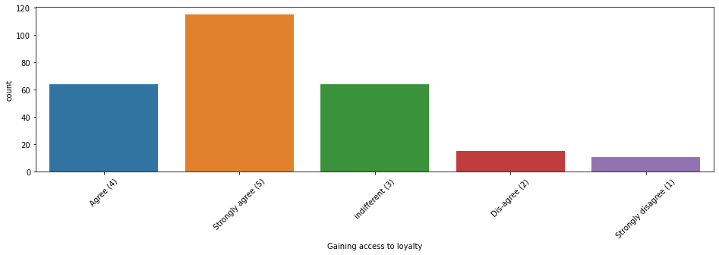

Strongly agree (5) 115

indifferent (3) 64

Agree (4) 64

Dis-agree (2) 15

Strongly disagree (1) 11

Name: Gaining access to loyalty, dtype: int64

plt.figure(figsize=(15,5))

plt.xticks(rotation=45)

print(cus_ret['User satisfaction cannot exist without trust'].value_counts())

sns.countplot(cus_ret['User satisfaction cannot exist without trust'])

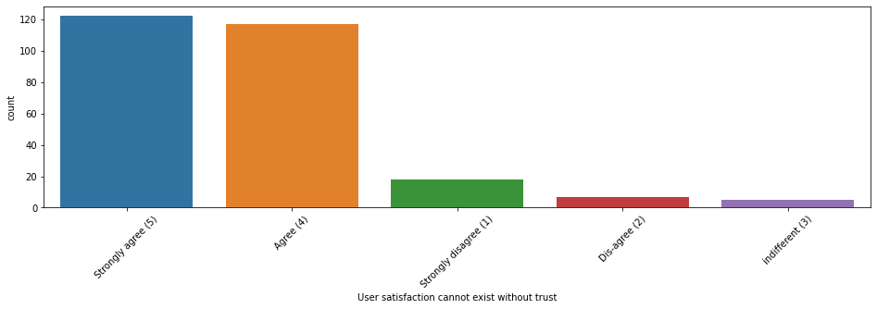

Strongly agree (5) 122

Agree (4) 117

Strongly disagree (1) 18

Dis-agree (2) 7

indifferent (3) 5

Name: User satisfaction cannot exist without trust, dtype: int64

plt.figure(figsize=(15,5))

plt.xticks(rotation=45)

print(cus_ret['Provision of complete and relevant product information'].value_counts())

sns.countplot(cus_ret['Provision of complete and relevant product information'])

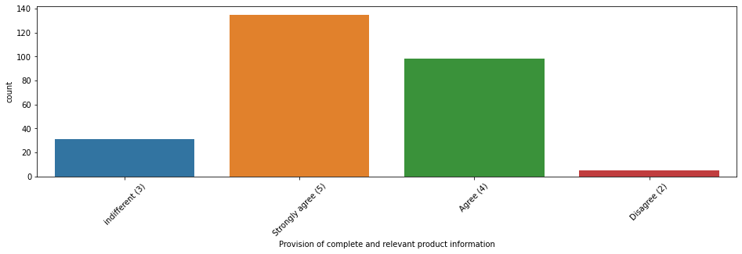

Strongly agree (5) 135

Agree (4) 98

indifferent (3) 31

Disagree (2) 5

Name: Provision of complete and relevant product information, dtype: int64

plt.figure(figsize=(15,5))

plt.xticks(rotation=45)

print(cus_ret['The Convenience of patronizing the online retailer'].value_counts())

sns.countplot(cus_ret['The Convenience of patronizing the online retailer'])

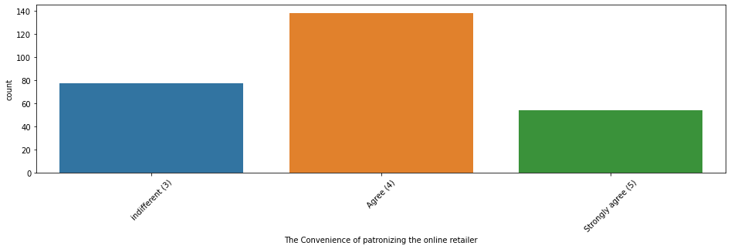

Agree (4) 138

indifferent (3) 77

Strongly agree (5) 54

Name: The Convenience of patronizing the online retailer, dtype: int64

plt.figure(figsize=(15,5))

plt.xticks(rotation=45)

print(cus_ret['gratification shopping on your favorite e-tailer'].value_counts())

sns.countplot(cus_ret['gratification shopping on your favorite e-tailer'])

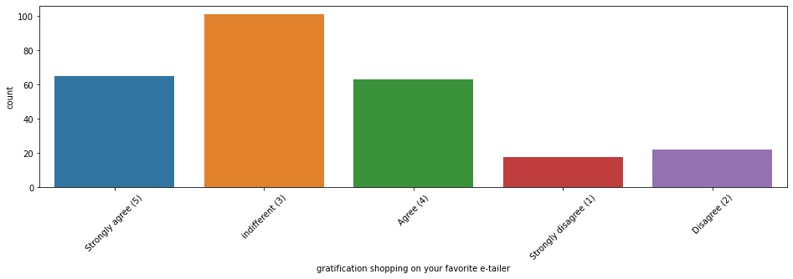

indifferent (3) 101

Strongly agree (5) 65

Agree (4) 63

Disagree (2) 22

Strongly disagree (1) 18

Name: gratification shopping on your favorite e-tailer, dtype: int64

plt.figure(figsize=(15,5))

plt.xticks(rotation=45)

print(cus_ret['enhances your social status'].value_counts())

sns.countplot(cus_ret['enhances your social status'])

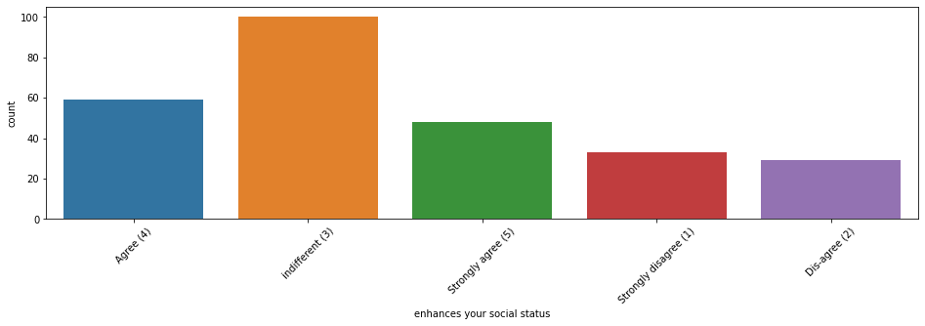

indifferent (3) 100

Agree (4) 59

Strongly agree (5) 48

Strongly disagree (1) 33

Dis-agree (2) 29

Name: enhances your social status, dtype: int64

plt.figure(figsize=(15,5))

plt.xticks(rotation=45)

print(cus_ret['Shopping on the website helps you fulfill certain roles'].value_counts())

sns.countplot(cus_ret['Shopping on the website helps you fulfill certain roles'])

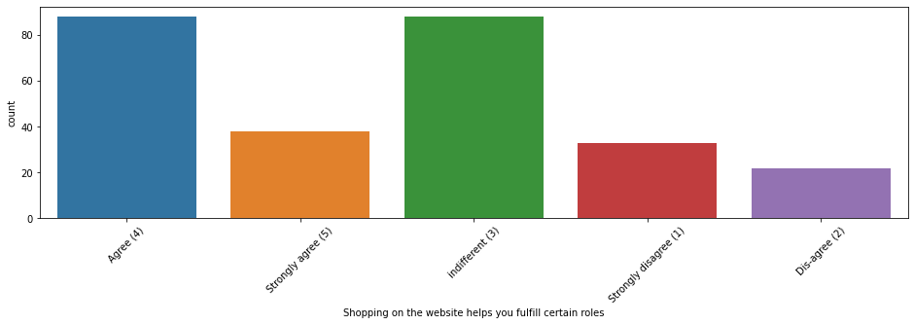

indifferent (3) 88

Agree (4) 88

Strongly agree (5) 38

Strongly disagree (1) 33

Dis-agree (2) 22

Name: Shopping on the website helps you fulfill certain roles, dtype: int64

**Conclusion from Customer's Feed-Back**

**People strongly agree that ---**

**1 Website has user friendly interface.**

**2 Payment method Should be convenient.**

**3 Responsiveness, availability of several communication channels (email, online rep**

**, twitter, phone etc ) is necessary.**

**4 Online shopping gives monetary benefit and discounts to the customers.**

**5 Displaying quality Information on the website improves satisfaction of customers.**

**6 Return and replacement policy of the e-tailer is important for purchase decision.**

**7 Doing online shopping give them value of money spend.**

**8 Shopping on the website give them sense of adventure.**

**9 Being able to guarantee the privacy of the customer**

**10 User derive satisfaction while shopping on a good quality website or application.**

**11 Shopping online is convenient and flexible.**

**12 Gaining access to loyalty programs is a benefit of shopping online.**

**13 User satisfaction exist when they have trust one website.**

**14 Their should be provision of complete and relevant product information website.**

**15 They feel gratification shopping on your favorite e-tailer.**

**16 The Convenience of patronizing the online retailer.**

**Users have indifferent opinion that shopping on their preferred e-tailer enhances their**

**social status.**

**Users have mixed reaction on whether shopping on website helps them to fulfil certain**

**roles some agree it some are indifferent.**

.

Different Websites or

online Shopping Platform

Used by Customers

plt.figure(figsize=(15,5))

plt.xticks(rotation=50)

print(cus_ret['Easy to use website or application'].value_counts())

cus_ret['Easy to use website or application'].value_counts().plot(kind="bar")

plt.show()

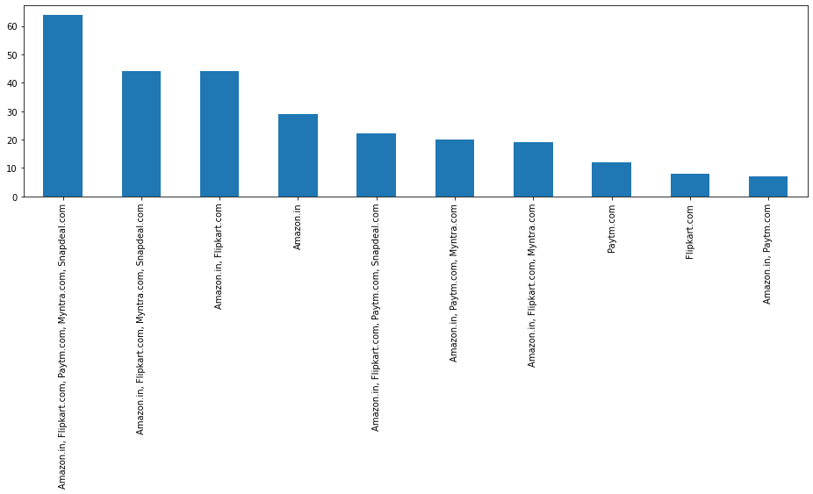

Amazon.in, Flipkart.com, Paytm.com, Myntra.com, Snapdeal.com 64

Amazon.in, Flipkart.com, Myntra.com, Snapdeal.com 44

Amazon.in, Flipkart.com 44

Amazon.in 29

Amazon.in, Flipkart.com, Paytm.com, Snapdeal.com 22

Amazon.in, Paytm.com, Myntra.com 20

Amazon.in, Flipkart.com, Myntra.com 19

Paytm.com 12

Flipkart.com 8

Amazon.in, Paytm.com 7

Name: Easy to use website or application, dtype: int64

**As per above graph, Majority of the customers are using**

**Amazon.in, Flipkart.com, Paytm.com, Myntra.com, Snapdeal.com**

**as It is Easy to use Websites and as our earlier analysis on device**

**using category shows that Most of the people are using**

**Smartphone and all this online platform has their own mobile**

**application which has lots of features even and Easy to use**

**Amazon is the choice of among 90% Users, Showing very clear in**

**above Graph.**

plt.figure(figsize=(15,5))

plt.xticks(rotation=50)

print(cus_ret['Wild variety of product on offer'].value_counts())

cus_ret['Wild variety of product on offer'].value_counts().plot(kind="bar")

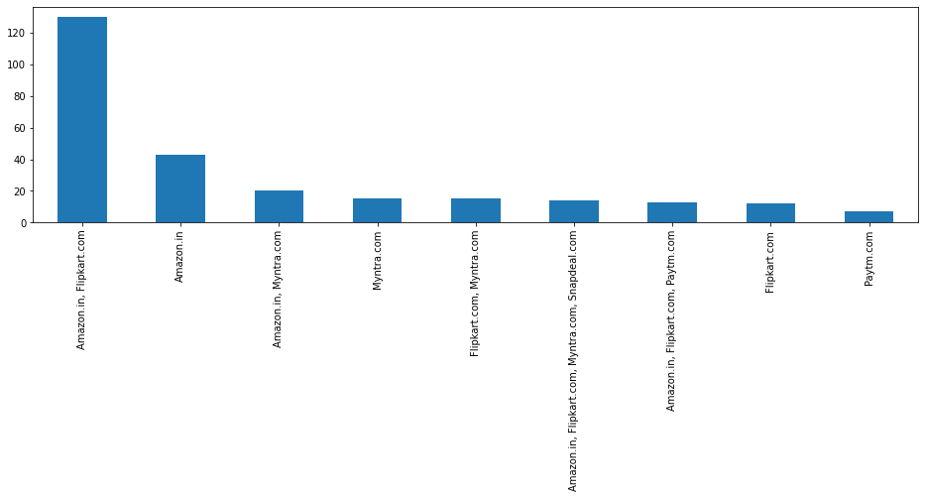

Amazon.in, Flipkart.com 130

Amazon.in 43

Amazon.in, Myntra.com 20

Myntra.com 15

Flipkart.com, Myntra.com 15

Amazon.in, Flipkart.com, Myntra.com, Snapdeal.com 14

Amazon.in, Flipkart.com, Paytm.com 13

Flipkart.com 12

Paytm.com 7

Name: Wild variety of product on offer, dtype: int64

**Website like Amazon and Flipkart have visual appealing webpage**

**layout and they offer wild variety of products.**

plt.figure(figsize=(15,5))

plt.xticks(rotation=50)

print(cus_ret['Reliability of the website or application'].value_counts())

cus_ret['Reliability of the website or application'].value_counts().plot(kind="bar")

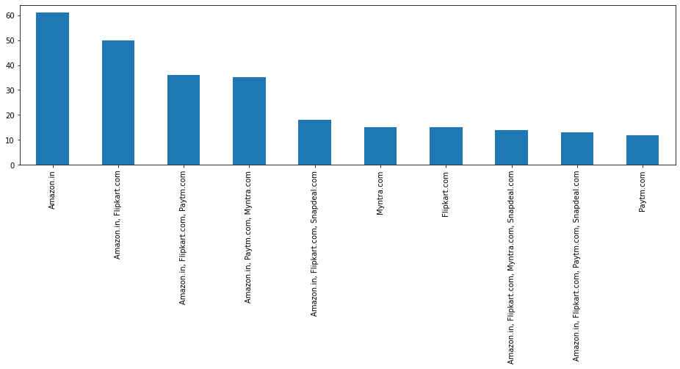

Amazon.in 61

Amazon.in, Flipkart.com 50

Amazon.in, Flipkart.com, Paytm.com 36

Amazon.in, Paytm.com, Myntra.com 35

Amazon.in, Flipkart.com, Snapdeal.com 18

Myntra.com 15

Flipkart.com 15

Amazon.in, Flipkart.com, Myntra.com, Snapdeal.com 14

Amazon.in, Flipkart.com, Paytm.com, Snapdeal.com 13

Paytm.com 12

Name: Reliability of the website or application, dtype: int64

**For Reliability of the website or application**

**61 out of 269 customers choose amazon and**

**50 out of 269 customers choose amazon and flipkart.**

plt.figure(figsize=(15,5))

plt.xticks(rotation=50)

print(cus_ret['Privacy of customers’ information'].value_counts())

sns.countplot(cus_ret['Privacy of customers’ information'])

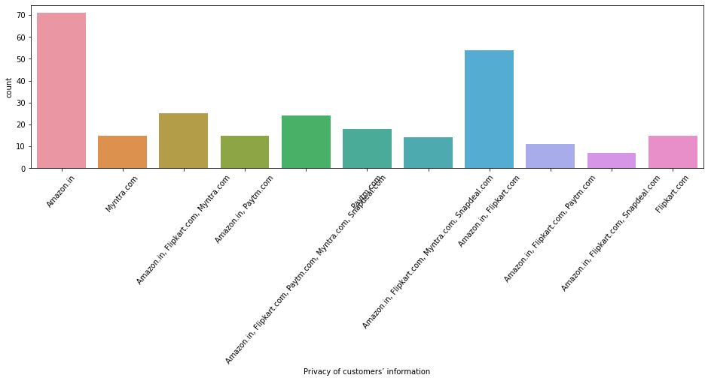

Amazon.in 71

Amazon.in, Flipkart.com 54

Amazon.in, Flipkart.com, Myntra.com 25

Amazon.in, Flipkart.com, Paytm.com, Myntra.com, Snapdeal.com 24

Paytm.com 18

Myntra.com 15

Amazon.in, Paytm.com 15

Flipkart.com 15

Amazon.in, Flipkart.com, Myntra.com, Snapdeal.com 14

Amazon.in, Flipkart.com, Paytm.com 11

Amazon.in, Flipkart.com, Snapdeal.com 7

Name: Privacy of customers’ information, dtype: int64

plt.figure(figsize=(15,5))

plt.xticks(rotation=50)

print(cus_ret['Security of customer financial information'].value_counts())

sns.countplot(cus_ret['Security of customer financial information'])

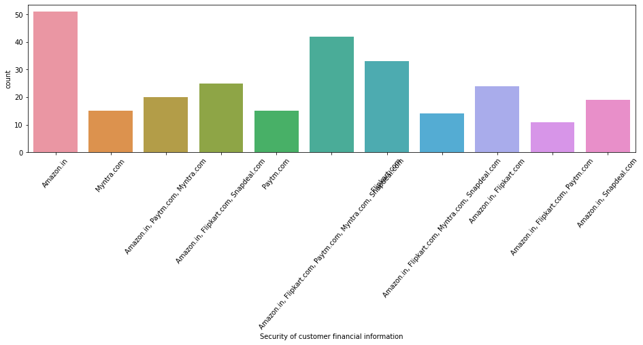

Amazon.in 51

Amazon.in, Flipkart.com, Paytm.com, Myntra.com, Snapdeal.com 42

Flipkart.com 33

Amazon.in, Flipkart.com, Snapdeal.com 25

Amazon.in, Flipkart.com 24

Amazon.in, Paytm.com, Myntra.com 20

Amazon.in, Snapdeal.com 19

Myntra.com 15

Paytm.com 15

Amazon.in, Flipkart.com, Myntra.com, Snapdeal.com 14

Amazon.in, Flipkart.com, Paytm.com 11

Name: Security of customer financial information, dtype: int64

plt.figure(figsize=(15,5))

plt.xticks(rotation=50)

print(cus_ret['Perceived Trustworthiness'].value_counts())

cus_ret['Perceived Trustworthiness'].value_counts().plot(kind="line")

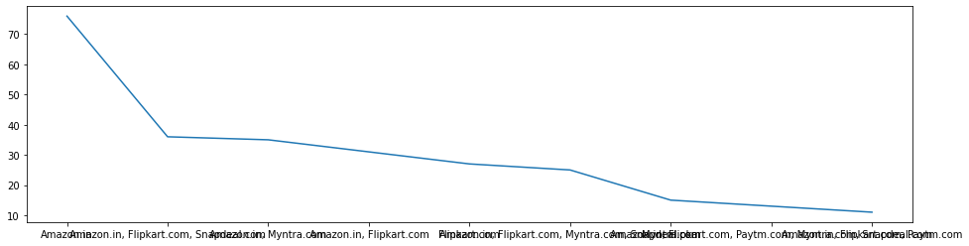

Amazon.in 76

Amazon.in, Flipkart.com, Snapdeal.com 36

Amazon.in, Myntra.com 35

Amazon.in, Flipkart.com 31

Flipkart.com 27Amazon.in, Flipkart.com, Myntra.com, Snapdeal.com 25

Myntra.com 15

Amazon.in, Flipkart.com, Paytm.com, Myntra.com, Snapdeal.com 13

Amazon.in, Flipkart.com, Paytm.com 11

Name: Perceived Trustworthiness, dtype: int64

plt.figure(figsize=(15,5))

plt.xticks(rotation=50)

print(cus_ret['Longer delivery period'].value_counts())

sns.countplot(cus_ret['Longer delivery period'])

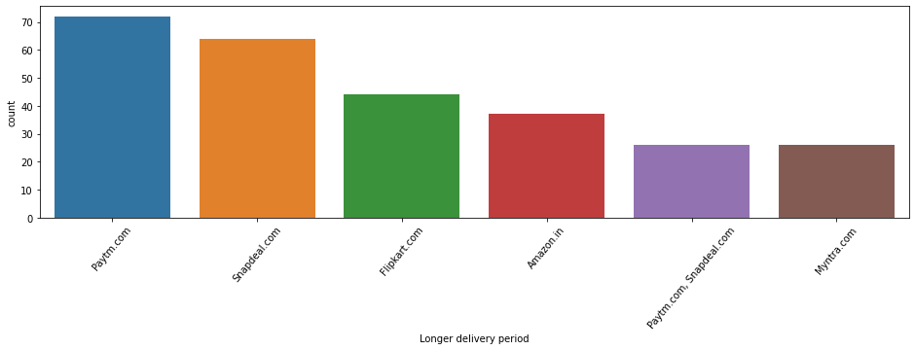

Paytm.com 72

Snapdeal.com 64

Flipkart.com 44

Amazon.in 37

Paytm.com, Snapdeal.com 26

Myntra.com 26

Name: Longer delivery period, dtype: int64

**In Longer delivery period paytm.com topped the list.**

plt.figure(figsize=(15,5))

plt.xticks(rotation=50)

print(cus_ret['Change in website/Application design'].value_counts())

sns.countplot(cus_ret['Change in website/Application design'])

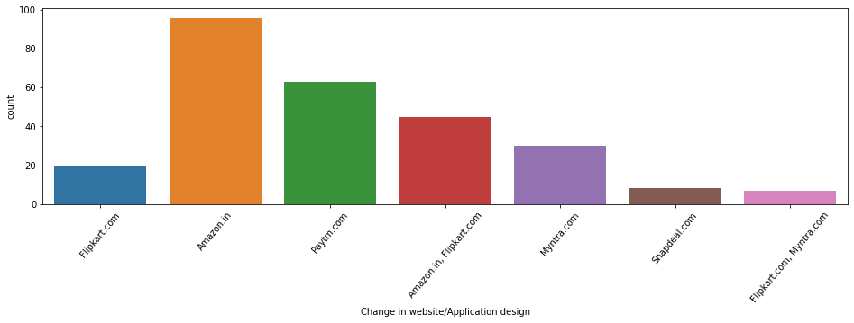

Amazon.in 96

Paytm.com 63

Amazon.in, Flipkart.com 45

Myntra.com 30

Flipkart.com 20

Snapdeal.com 8

Flipkart.com, Myntra.com 7

Name: Change in website/Application design, dtype: int64

**In Change in website/Application design amazon.in topped the list.**

plt.figure(figsize=(15,5))

plt.xticks(rotation=50)

print(cus_ret['Website is as efficient as before'].value_counts())

sns.countplot(cus_ret['Website is as efficient as before'])

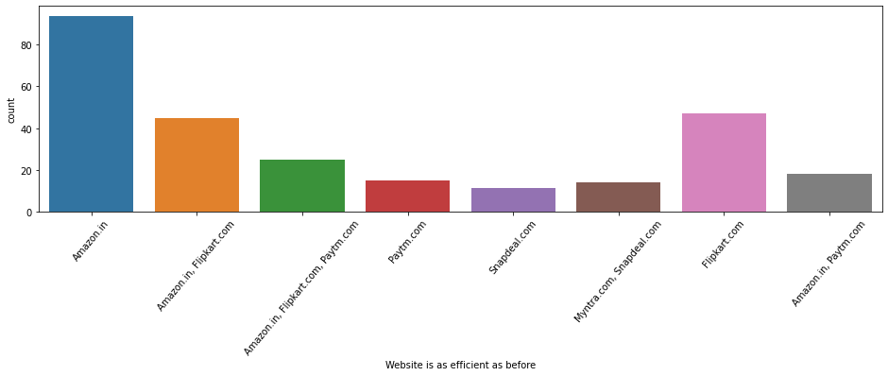

Amazon.in 94

Flipkart.com 47

Amazon.in, Flipkart.com 45

Amazon.in, Flipkart.com, Paytm.com 25

Amazon.in, Paytm.com 18

Paytm.com 15Myntra.com, Snapdeal.com 14

Snapdeal.com 11

Name: Website is as efficient as before, dtype: int64

plt.figure(figsize=(15,5))

plt.xticks(rotation=50)

print(cus_ret['Which of the Indian online retailer would you recommend to a

friend'].value_counts())

sns.countplot(cus_ret['Which of the Indian online retailer would you recommend to a friend'])

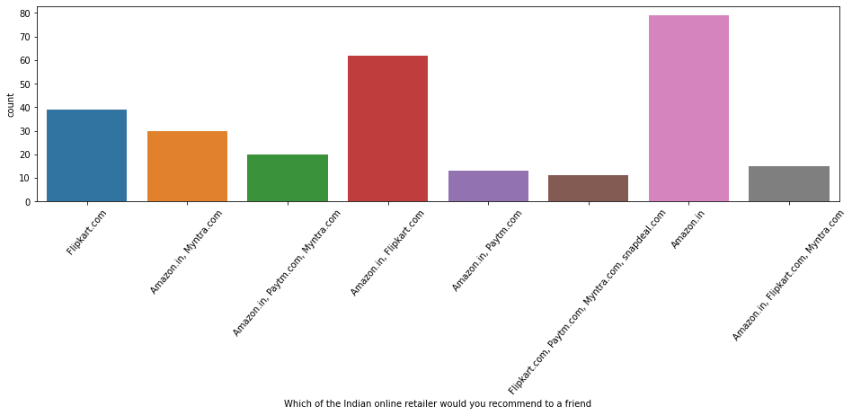

**Which of the Indian online retailer would you recommend to a**

**friend?**

**79 out of 269 choose amazon which tops the list**

**2nd most is 62 out of 269 choose amazon and flipkart.**

**Conclusion**

As in the final countplot in which user were asked which online retailer they would

recommend to a friend in this Amazon.in topped the list because it is providing all

the features that users want. Website is efficient and it is fast loading , it gives

complete , relevant description and information of products . It is reliable and quick

to complete the purchase. Amazon give speedy delivery to its customers and there

are several payment options available on the website. It provides online assistance

through multi channels. Providing good deals on products. Its website have visual

appealing webpage layout and they offer wide variety of products and its

application is easy to use . lastly the main thing why user recommend it is because

of its Trustworthiness and its robust Security in protecting customer financial

information and their Privacy information .

These all features make it top the list of recommended online retailer .Providing

these features it is retaining its customers.

They are some cons like the amazon website topping the list In Frequent disruption

when moving from one page to another this con company should see and improve

it to give overall best experience to the users.

Challenges:

It was difficult to read each column and comparing with others on the dataset in

notebook as it took some time to understand and analyse it a proper way.

Key Findings and Conclusions of the Study:

I used various visualization methods and understood the EDA in a better way

This customer satisfaction can be used as an impact of eCommerce market

development as well as for economic development of the country.

Learning Outcomes of the Study in respect of Data Science:

As per as learning outcomes is concerned, I have learnt the following things:

i) Visualization helps us understand the data graphically.

ii) I also understand the about reading various related features and

importance of them in the whole dataset.

Limitations of this work and Scope for Future Work :

Since I have only used a sample dataset, hence sometimes it is difficult to

understand the overall impact of this customer feedback at a larger scale